NANOTECHNOLOGY TALKS SERIES-5
“ELECTROSPUN NANOFIBERS APPLICATIONS IN TISSUE ENGINEERING”
Thursday, 19th December , 2019
At 11:00 AM
Technology Faculty Conference Hall
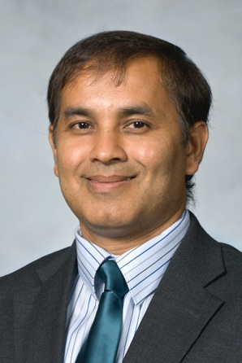
Morshed Khandaker
Professor, Department of Engineering and Physics
University of Central Oklahoma, USA

Morshed Khandaker is a Professor of Mechanical Engineering in the Department of Engineering and Physics at the University of Central Oklahoma, Edmond, Oklahoma. He earned his M.S. and PhD from Texas Tech University, Lubbock, Texas. His research area is solid mechanics and mechatronics, specifically electrospun nanofiber manufacturing and application technologies for improving the biological performances of implant materials. He has mentored two post-doctoral, 18 graduate, and 82 undergraduate research assistants. He has received several state and university grants to fund the student research projects. He is an author of 26 peer-reviewed journal articles and presented 86 conference articles/abstracts, where mainly undergraduate and graduate students are co-authors. He is an inventor of 5 granted patents. He has collaborated with faculties and clinicians from UCO and other state universities, local industries, and hospitals. He has received several merit awards in the excellence of teaching and research from UCO due to his outstanding contribution in research and scholar activities.

Abstract
My research group is working on electrospun nanofiber applications, investigating unique approach of electrospun polycaprolactone (PCL) nanofiber coating to improve the biological performances. Implant failure due to poor integration of the implant with the native tissue is a common problem in various orthopedic and orthodontic implants. My research invented a process by which polymeric fibers can be connected on intraosseous implant devices to enhance osseointegration capabilities of implants. In vivo studies using rabbit proofs the efficacy of our treatment methods on orthopedic (non-cement and cemented) and orthodontic titanium implants. Our study invented a process by which hydrogel membrane can be stacked and interspersed between multiple layers of PCL NFM, binding them together to produce a 3D hydrogel-PCL scaffold. We reported in vitro biological efficacy of PCL-PEGDA scaffolds using mouse osteoblast cells and human bone morrow stem cells. Our in vivo studies using Sprague Dawley rats animal model found that PCL-PEGDA scaffold successfully generated new cell matrix and restore intervertebral disc space.
In our research, we are combining the excellent mechanical and biodegradable PCL properties with the beneficial biological properties of type I collagen to create a CG-PCL graft as a skin substitute. We have successfully examined in vivo efficacy of CG-PCL skin graft using inbred Wistar rat animal model.

