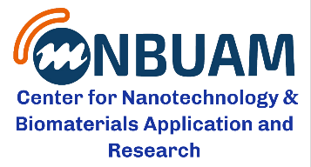
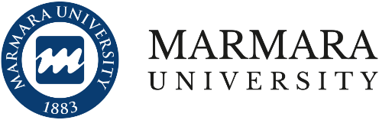

NANOTECHNOLOGY TALKS SERIES-6
“Material research in the energetic,
Possibility for research and education collaboration”
Thuesday, 4th February , 2020
At 10:30 – 11:30 AM
Technology Faculty Conference Hall
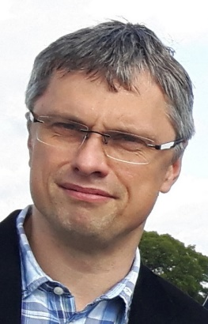
Prof. Ing. Karel Fraňa, Ph.D.
Professor, Department of the Power Energy Equipment
Technical University in Liberec, Czech Republic

Positions: from October 2005 – present: Department of the Power Energy Equipment at the Technical University in Liberec, Czech Republic, from July 2011 - Vice-Dean of the Faculty of Mechanical Engineering April 2001- September 2005: co-worker in the grant of the Collaborative Research Centre SFB 609, German “Deutsche Forschungsgemeinschaft”, Technical University in Dresden, Institute for Aerospace Engineering, Germany.
Publications: More than 20 publications in International Journals, more than 50 conference papers, more than 10 contributions in books.
Projects Supervisor of more than 10 projects at EU level or domestic industrial research level.
Courses and lectures Thermodynamics, Technical University in Liberec, Numerical Methods in the heat and mass transfer (CFD), Technical University in Liberec
General research activities: Thermodynamics and Fluid Mechanics, Heat transfer Applied mathematical methods, Finite-Element method (FEM), Magnetohydrodynamics Energetics and Energy efficienty, effective using of energy resources

Abstract
Several research topics in the field of the energy efficiency in the material production and energy conversion will be introduced in the frame of the presentation. How to save energy or how to use the energy resources more effectively is a crucial issue of current research worldwide. New research methods e.g. the computational fluid dynamics can be used to optimize the material production (e.g. during the foaming process) in order to decrease the energy consumption and increase the material quality and structure homogeneity. Furthermore, new smart materials can offer possibilities to effectively use the energy or even to harvest lost energy. In order to demonstrate application of research various experimental models were designed and obtained results mostly measured were successfully applied for a validation of theoretical or numerical results.

